Research Question: Does the Value of Fair Pay Vary Between Genders?
Table 1A.
Group Statistics
 | gender | N | Mean | Std. Deviation | Std. Error Mean
paid | male | 115 | 6.84 | 1.542 | .144
 | female | 276 | 6.74 | 1.861 | .112
Table 1B.
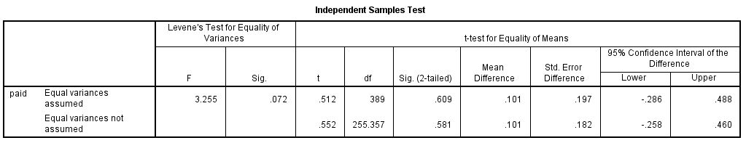
*Cohen’s D Calculation .512x2 = 1.024 and √ (389) = 19.723
1.024 / 19.723 = .0519
Cohen’s D= .0519
Methods: An independent-samples t-test was conducted to compare the Value of fair pay earned between male (115) and female (276) participants. People were assessed through a survey administration, (LSQ) Life Sphere Questionnaire.
Results: There was no significant differences in the value of money between male (M = 6.84, SD = 1.542) and female (M = 6.74. SD = 1.861); t (389) = 0.611, p = .512, with an effect size of d = .0519. The results are based on a sample size (n=391).
Conclusion: These results indicated that gender of participants does not have an effect on the value of income equality score. Specifically, the results suggest that gender does not affect whether or not beliefs change in whether or not people should be compensated based on their effort of labor. Furthermore, our results may represent a population bias due to convenience sampling. This sample displays a disproportionate number of women (276) compared to men (115) in our study.

